Department of Commerce
Activities for the academic year

Department Activities
2015-2016
INDEX
S. No | Date | Name of the Activity | No. of Students Participated
1 | 21-09-2015 | Industrial Visit | 35
2 | 07-10-2015 | Field Visit | 40
3 | 28-09-2015 | Extension Activity | -
4 | 28-09-2015 | Extension Activity | -
5 | 09-11-2015 | Guest Lecture | 40
6 | 02-12-2015 | Guest Lecture | 100
7 | 03-08-2015 | Student Seminar | 52

Industrial Visit to Vellore, Tamilnadu September 2015.
35 Students of B.Com Final Year along with staff members of the Dept. of Commerce Sri. V. Hari Hara Prasad & Kum. P. Srilatha visited Florence Shoe Industry at Vellore, Tamilnadu. The Students acquired the knowledge regarding shoe making techniques, Capital Budgeting, Labour Employment, Employee appointment and wages paid to the workers.
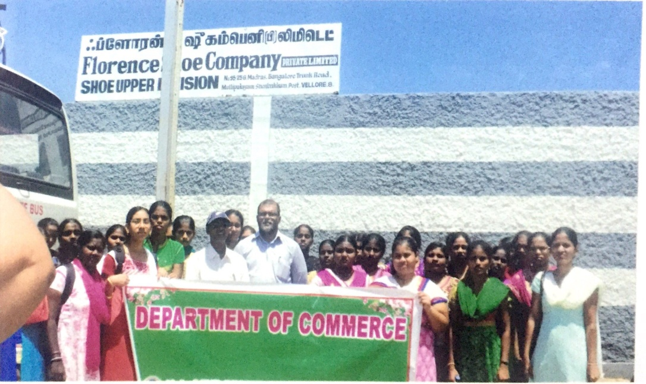
Industrial visit to Florence Shoe Company

Field Visit to Syndicate Bank 07-10-2015
B.Com II Year (Com & Gen) students visited Syndicate Bank, Chirala. They learned the functioning of A.T.M. (Automated Teller Machine) and the banking transactions like withdrawal and deposit forms. They got the knowledge of interest rates of various fixed deposits. The bank manager explains the students the day to day changes in banking sector.
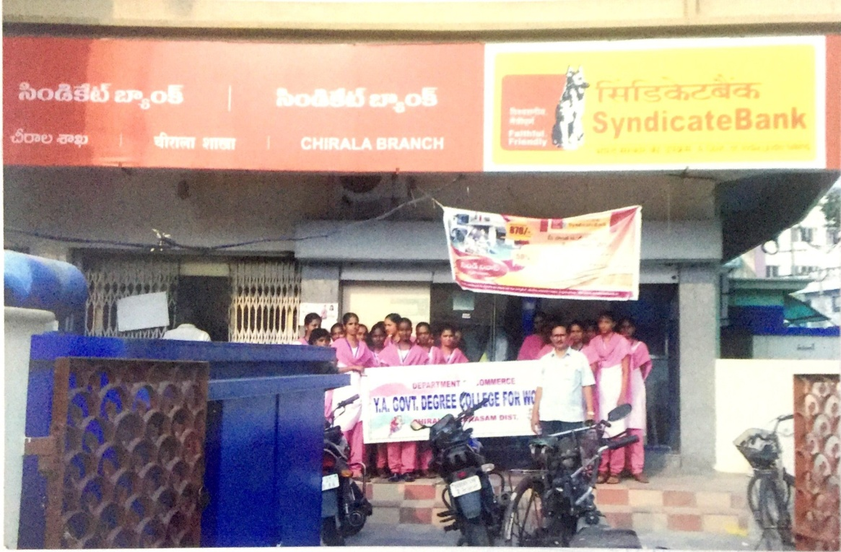
Field Visit to Syndicate Bank

Extension Activities
28-09-2015
Staff Member give cash prize to the student who secured highest marks in university exams
- Sri.V.Hari Hara Prasad, lecturer in commerce gave Rs.6000 towards payment of M.Com fee to Kum. S.Siva Parvathi ,Old students in the College.
- Kum. P.Srilatha, Lecturer in commerce gave cash prizes Rs.500.

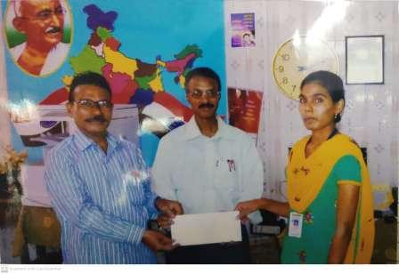

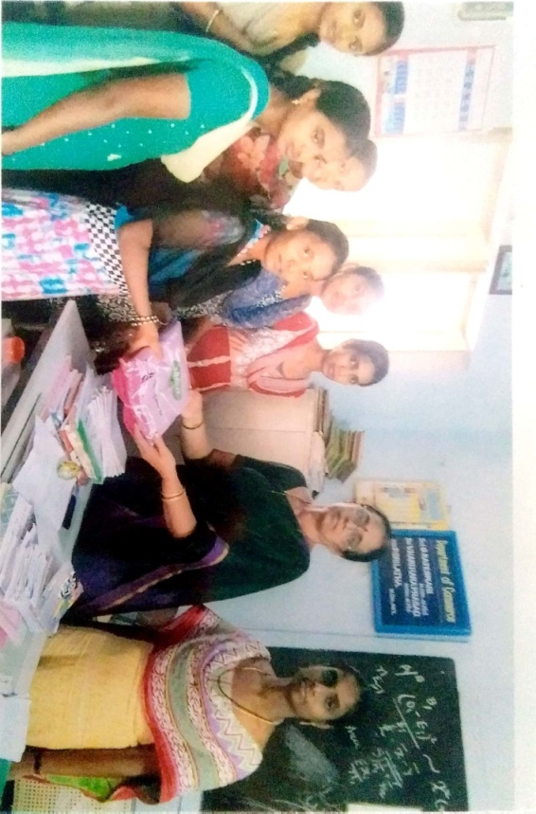
- Smt. G.Rajeswari, Incharge of the Department has distributed free uniform to the poor students.

Guest Lecture by Faculty Member

Sri K. Ravi Kumar lecturer in Commerce Y.A.Govt.Degree College for Women, Chirala. He was delivered Guest Lecture at Andhra kesari Vidya kendram (A.K.V.K) Degree College Ongole. Topic delivered E-Commerce .

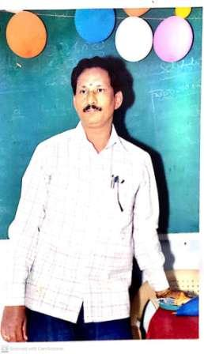

Guest Lecture by Faculty Member

Sri V. Hari Hara Prasad lecturer in Commerce Y.A.Govt.Degree College for Women, Chirala. He attended and delivered a Guest Lecture at TRR Govt. Degree College, Kandukur. On the topic Non – “Performing Assets – Future of the Banking System “.

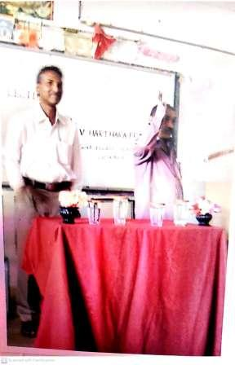

Y.A. Govt Degree College For Women, Chirala
Department of Commerce

Student Seminar on Correlation
Date : 03-08-2015

Department of commerce has organized a class room seminars for II B. Com
Students for exposer of various topics in statistics Kum. D. Sai Lakshmi gave a
seminar on “Correlation”. All the II Year students of this college participated .

